Overview of Control Structures
- Branching structures perform a test and then execute some lines of code, but not others.
  - if … else… is generally used to select one of two sets of lines to execute based on the condition to be met.
  - switch … case … is generally used to select one set of lines to execute from many possibilities.
- Looping structures execute a set of code over and over
  - for loops: repetitions known
  - while loops: repetitions unknown
  - foreach loops are used to retrieve all the items in a collection.
- Functions allow the programmer to suspend the execution of the current code to run a set of instructions in another named code block before returning to the original code.

Using if Statement

The syntax for if is:
if (test)
statement-1

Or with an optional else branch:

if (test)
statement-1
else
statement-2

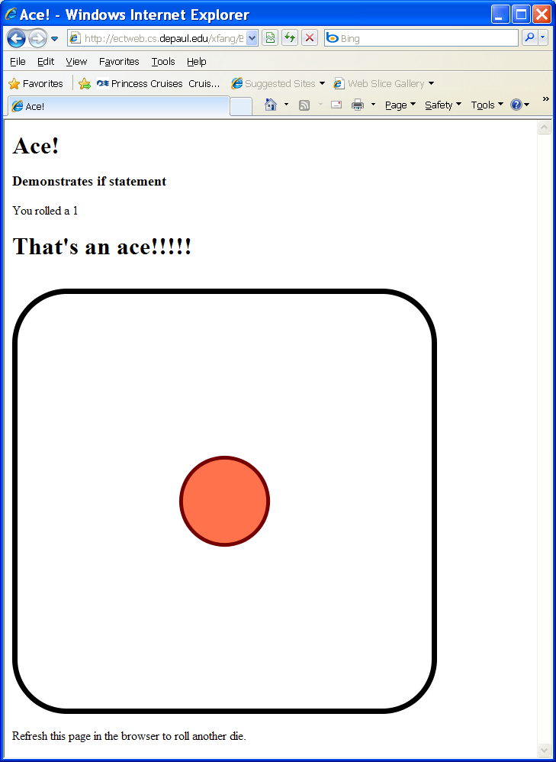 | Basics/Ace.php  <html>  <head>  <title>Ace!</title>  </head>  <body>  <h1>Ace!</h1>  <h3>Demonstrates if statement</h3>  <div>  <?php  $roll = rand(1,6);  print "You rolled a $roll";  if ($roll == 1){  print "<h1>That's an ace!!!!!</h1>";  } // end if  print "<br />";  print "<img src = \"images/Dice-$roll.png\" alt = \"die: $roll\" />";  ?>  </div>  <p>  Refresh this page in the browser to roll another die.  </p>  </body>  </html>

Using else Clause
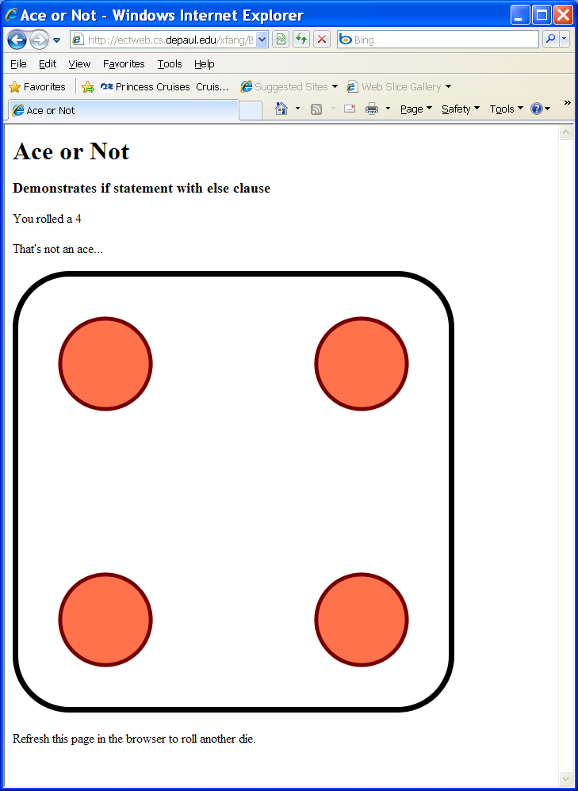 | Basics/AceorNot.php  <html>  <head>  <title>Ace or Not</title>  </head>  <body>  <h1>Ace or Not</h1>  <h3>Demonstrates if statement with else clause</h3>  <div>  <?php  $roll = rand(1,6);  print "<p>You rolled a $roll</p> \n";  if ($roll == 1){  print "<h1>That's an ace!!!!!</h1> \n";  } else {  print "<p>That's not an ace...</p> \n";  } // end if  print "<img src = \"images/Dice-$roll.png\" alt = \"$roll\" />";  ?>  <p>Refresh this page in the browser to roll another die.</p>  </div>  </body>

Working with Multiple else if Clause
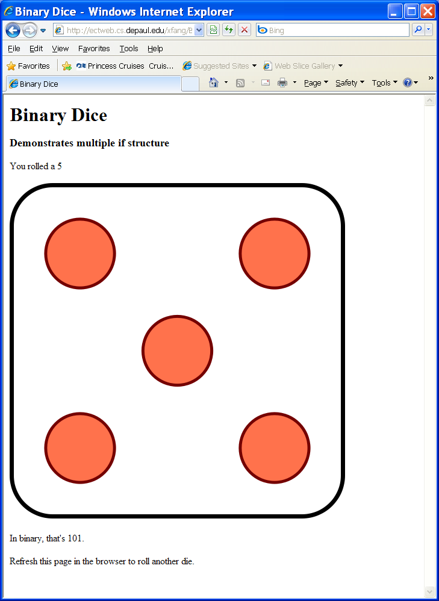 | Basics/Binarydice.php  <html>  <head>  <title>Binary Dice</title>  </head>  <body>  <h1>Binary Dice</h1>  <h3>Demonstrates multiple if structure</h3>  <?php  $roll = rand(1,6);  if ($roll == 1){  $binValue = "001";  } else if ($roll == 2){  $binValue = "010";  } else if ($roll == 3){  $binValue = "011";  } else if ($roll == 4){  $binValue = "100";  } else if ($roll == 5){  $binValue = "101";  } else if ($roll == 6){  $binValue = "110";  } else {  print "I don't know that one...";  } // end if  print <<< HERE  <p>You rolled a $roll</p>  <p>  <img src = "images/Dice-$roll.png"  alt = "die: $roll" />  </p>  <p>  In binary, that's $binValue.  </p>  HERE;  ?>  <p>  Refresh this page in the browser to roll another die.  </p>  </body>  </html>

Using the Switch Structure
Basic syntax:
switch(expression)
{
case value-1:
statement-1;
statement-2;
...
[break;]
case value-2:

statement-3;
statement-4;
...
[break;]
...
[default:
default-statement;]
}
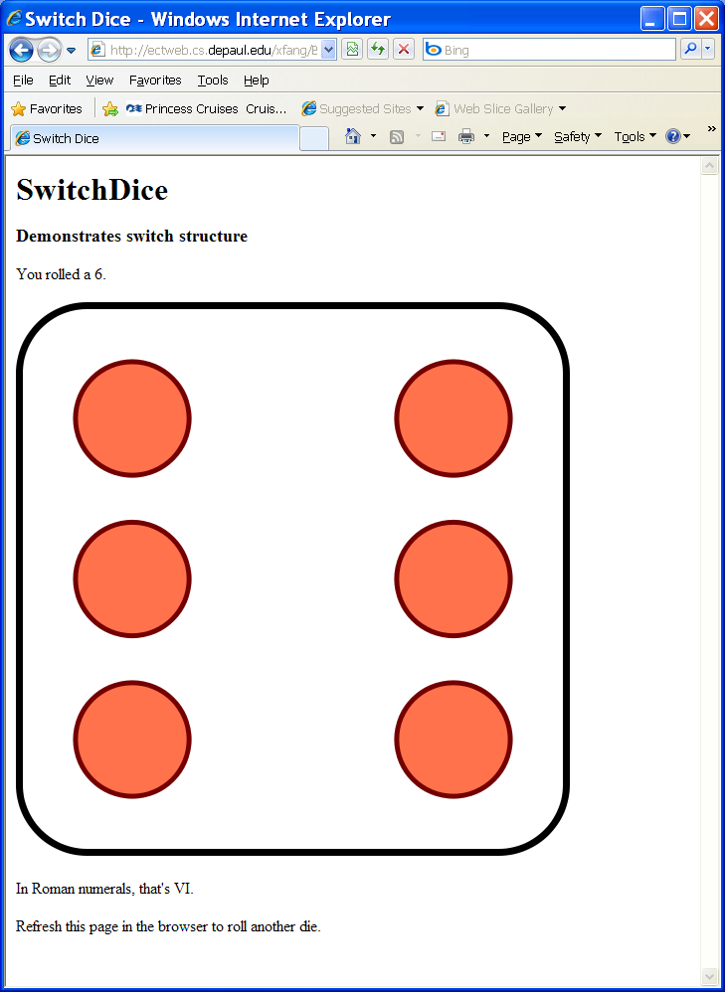 | Basics/Switchdice.php  <html>  <head>  <title>Switch Dice</title>  </head>  <body>  <h1>SwitchDice</h1>  <h3>Demonstrates switch structure</h3>  <?php  $roll = rand(1,6);  switch ($roll){  case 1:  $romValue = "I";  break;  case 2:  $romValue = "II";  break;  case 3:  $romValue = "III";  break;  case 4:  $romValue = "IV";  break;  case 5:  $romValue = "V";  break;  case 6:  $romValue = "VI";  break;  default:  print "This is an illegal die!";  } // end switch  print <<< HERE  <p>You rolled a $roll.</p>  <p>  <img src = "images/Dice-$roll.png"  alt = "die: $roll" />  </p>  <p>In Roman numerals, that's $romValue.</p>  HERE;  ?>  <p>  Refresh this page in the browser to roll another die.  </p>  </body>  </html>

Responding to Checkboxes
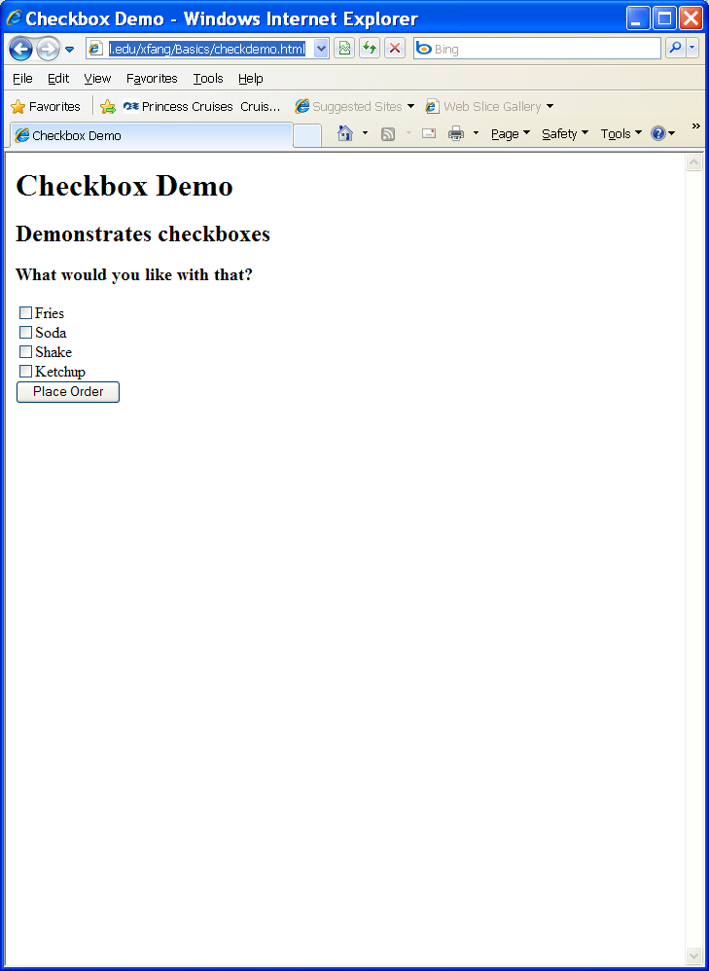  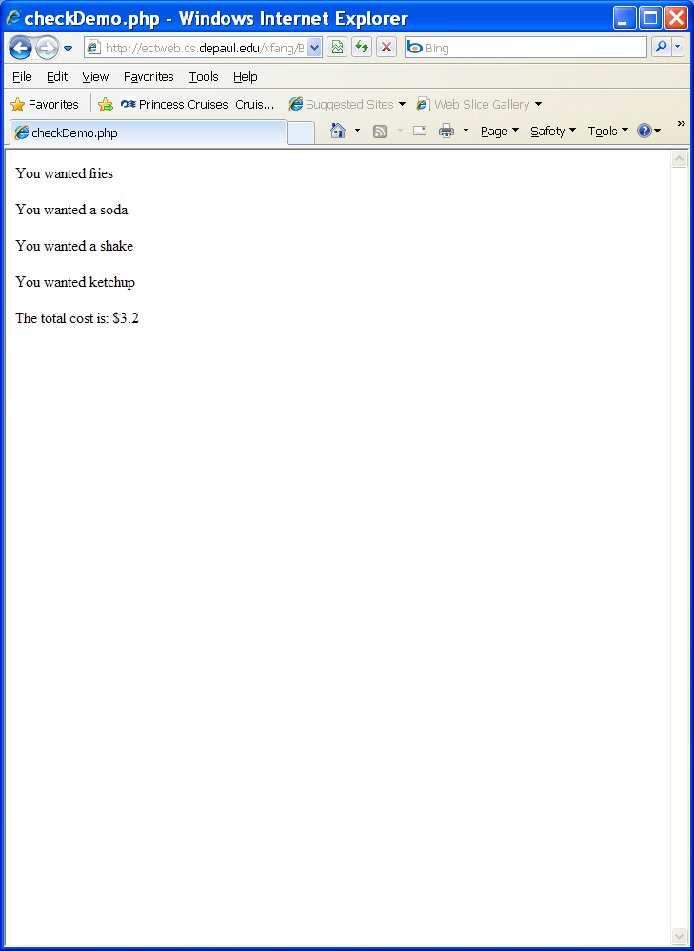 | Basics/checkdemo.html  <html>  <head>  <title>Checkbox Demo</title>  </head>  <body>  <h1>Checkbox Demo</h1>  <h2>Demonstrates checkboxes</h2>  <form action = "checkDemo.php"  method = "post">  <h3>What would you like with that?</h3>  <input type = "checkbox"  name = "chkFries"  value = "1.00">Fries<br>  <input type = "checkbox"  name = "chkSoda"  value = ".85">Soda<br>  <input type = "checkbox"  name = "chkShake"  value = "1.30">Shake<br>  <input type = "checkbox"  name = "chkKetchup"  value = ".05">Ketchup<br>  <input type = "submit" value="Place Order">  </form>  </body>  </html>  Basics/checkDemo.php  <html>  <head>  <title>checkDemo.php</title>  </head>  <body>  <?php  $total = 0;  if (filter_has_var(INPUT_POST, "chkFries")){  print "<p>You wanted fries</p> \n";  $total += filter_input(INPUT_POST, "chkFries");  }  if (filter_has_var(INPUT_POST, "chkSoda")){  print "<p>You wanted a soda</p> \n";  $total += filter_input(INPUT_POST, "chkSoda");  }  if (filter_has_var(INPUT_POST, "chkShake")){  print "<p>You wanted a shake</p> \n";  $total += filter_input(INPUT_POST, "chkShake");  }  if (filter_has_var(INPUT_POST, "chkKetchup")){  print "<p>You wanted ketchup</p> \n";  $total += filter_input(INPUT_POST, "chkKetchup");  }  print "<p>The total cost is: \$$total</p> \n";  ?>  </body>  </html>

Using Functions
What is a Function?
A function is a way of wrapping up a chunk of code and giving that chunk a name, so that you can use that chunk later in just one line of code. Functions are most useful when you will be using the code in more than one place, but they can be helpful even in one-use situations, because they can make your code much more readable.

Function Definition Syntax:

Function definitions have the following form:

function function-name ($argument-1, $argument-2, ..)
{
statement-1;
statement-2;
...
}

Function definitions have four parts:

- The special word function
- The name that you want to give your function
- The function's parameter list — dollar-sign variables separated by commas
- The function body — a brace-enclosed set of statements

The basic syntax for using (or calling) a function is:
function_name(expression_1, expression_2, ..., expression_n)

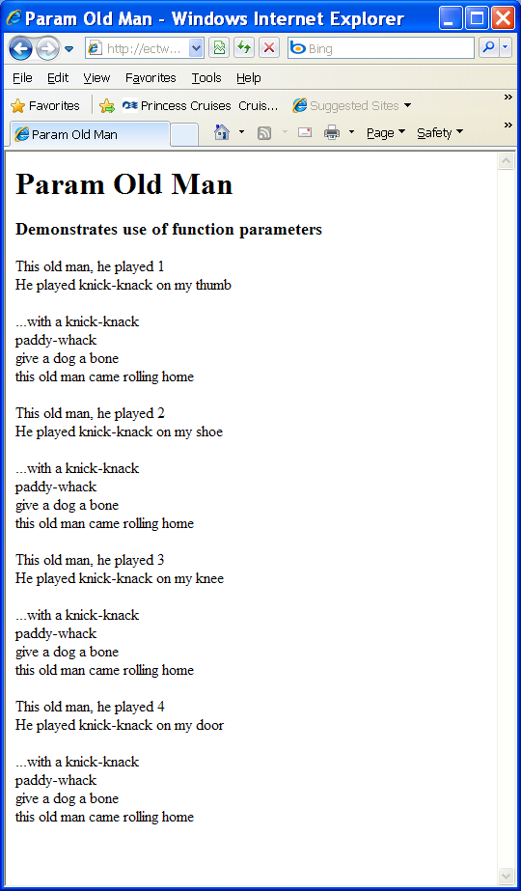 | Basics/functions.php  <html>  <head>  <title>Param Old Man</title>  </head>  <body>  <h1>Param Old Man </h1>  <h3>Demonstrates use of function parameters</h3>  <?php  print verse(1);  print chorus();  print verse(2);  print chorus();  print verse(3);  print chorus();  print verse(4);  print chorus();  function verse($stanza){  switch ($stanza){  case 1:  $place = "thumb";  break;  case 2:  $place = "shoe";  break;  case 3:  $place = "knee";  break;  case 4:  $place = "door";  break;  default:  $place = "I don't know where";  } // end switch  $output = <<<HERE  <p>  This old man, he played $stanza<br />  He played knick-knack on my $place  </p>  HERE;  return $output;  } // end verse  function chorus(){  $output = <<<HERE  <p>  ...with a knick-knack<br />  paddy-whack<br />  give a dog a bone<br />  this old man came rolling home<br />  </p>  HERE;  return $output;  } // end chorus  ?>  </body>  </html>

Scope of Variables
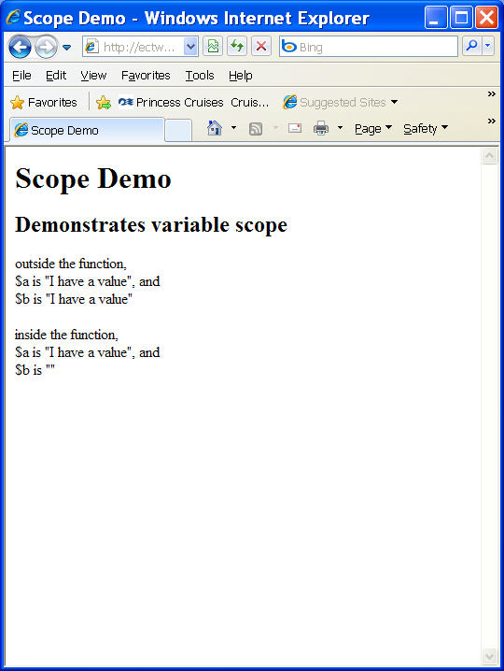 | Basics/scopedemo.php  <html>  <head>  <title>Scope Demo</title>  </head>  <body>  <h1>Scope Demo</h1>  <h2>Demonstrates variable scope</h2>  <?php  $a = "I have a value";  $b = "I have a value";  print <<<HERE  <p>  outside the function, <br />  \$a is "$a", and<br />  \$b is "$b"  </p>  HERE;  myFunction();  function myFunction(){  //make $a global, but not $b  global $a;  print <<<HERE  <p>  inside the function, <br />  \$a is "$a", and<br />  \$b is "$b"  </p>  HERE;  } // end myFunction  ?>  </body>  </html>

Using for loop
Syntax:
for (initial-expression;
termination-check;
loop-end-expression)
statement

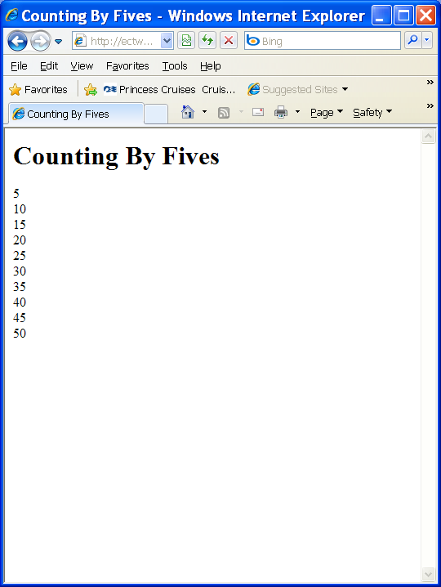 | Basics/counting.php  <html>  <head>  <title>  Counting By Fives  </title>  </head>  <body>  <h1>Counting By Fives</h1>  <?php  print "<p> \n";  for ($i = 5; $i <= 50; $i+= 5){  print "$i <br />\n";  } // end for loop  print "</p> \n";  ?>  </body>  </html>

Using while loop
Syntax:
while (condition)
statement

Or:
do statement
while (expression);

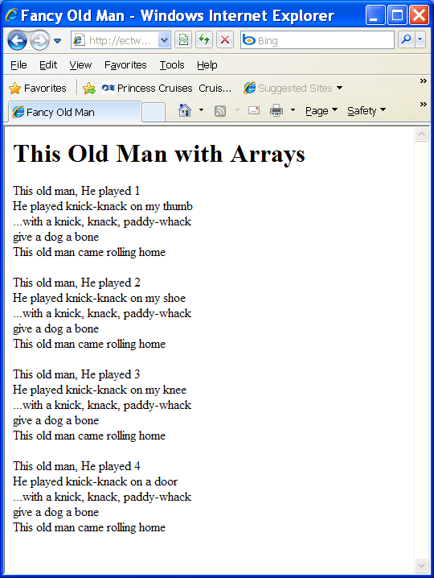 | Basics/whileloop.php  <html>  <head>  <title>  Fancy Old Man  </title>  </head>  <body>  <h1>This Old Man with Arrays</h1>  <?php  $place = array(  "",  "on my thumb",  "on my shoe",  "on my knee",  "on a door");  $verse=1;  //print out song  while ($verse <= 4){  print <<<HERE  <p>  This old man, He played $verse <br />  He played knick-knack $place[$verse] <br />  ...with a knick, knack, paddy-whack <br />  give a dog a bone <br />  This old man came rolling home  </p>  HERE;  $verse++;  } // end while loop  ?>  </body>  </html>
Break and Continue
The standard way to get out of a looping structure is for the main test condition to become false. The special commands break and continue offer an optional side exit from all the looping constructs, including while, do-while, and for:
- The break command exits the innermost loop construct that contains it.
- The continue command skips to the end of the current iteration of the innermost loop that contains it.
For example, the following code:

for ($x = 1; $x < 10; $x++)
{
// if $x is odd, break out
if ($x % 2 != 0)
break;
print("$x ");
}
prints nothing, because 1 is odd, which terminates the for loop immediately. On the other hand, the code:

for ($x = 1; $x < 10; $x++)
{
// if $x is odd, skip this loop
if ($x % 2 != 0)
continue;
print("$x ");
}

prints:
2 4 6 8

Terminating the execution
The exit() construct takes either a string or a number as argument, prints out the argument, and then terminates execution of the script. Everything that PHP produces up to the point of invoking exit() is sent to the client browser as usual, and nothing in your script after that point will even be parsed — execution of the script stops immediately. If the argument given to exit is a number rather than a string, the number will be the return value for the script's execution. Because exit is a construct, not a function, it's also legal to give no argument and omit the parentheses.
The die() construct is an alias for exit() and so behaves exactly the same way.
Working with fopen() and fclose()
Modes used with fopen()
Mode | Usage
r | Opens an existing file and reads data from it. The file pointer is placed at the beginning of the file.
r+ | Opens an existing file for reading or writing. The file pointer is placed at the beginning of the file.
w | Opens a file for writing. If a file with that name does not exist, the function creates a new file. If the file exists, the function deletes all existing content and places the file pointer at the beginning of the file.
w+ | Opens a file for reading and writing. If a file with that name does not exist, the function creates a new file. If the file exists, the function deletes all existing content and places the file pointer at the beginning of the file.
a | Opens a file for writing. If a file with that name does not exist, the function creates a new file. If the file exists, the function places the file pointer at the end of the file.
a+ | Opens a file for reading and writing. If a file with that name does not exist, the function attempts to create a new file. If the file exists, the function places the file pointer at the end of the file.

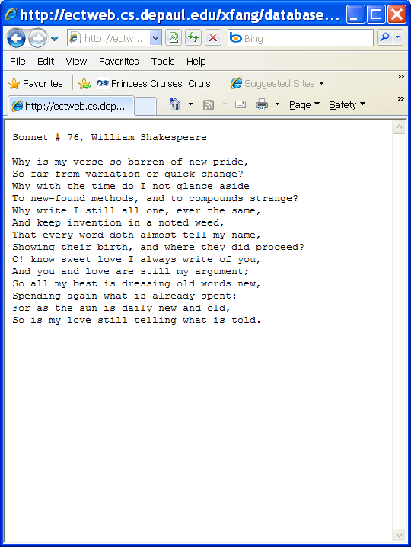 | Basics/savingfile.php  <html>  <head>  <title>SaveSonnet</title>  </head>  <body>  <?php  $sonnet76 = <<<HERE  Sonnet # 76, William Shakespeare  Why is my verse so barren of new pride,  So far from variation or quick change?  Why with the time do I not glance aside  To new-found methods, and to compounds strange?  Why write I still all one, ever the same,  And keep invention in a noted weed,  That every word doth almost tell my name,  Showing their birth, and where they did proceed?  O! know sweet love I always write of you,  And you and love are still my argument;  So all my best is dressing old words new,  Spending again what is already spent:  For as the sun is daily new and old,  So is my love still telling what is told.  HERE;  $fp = fopen("../Database/sonnet76.txt", "w");  fputs($fp, $sonnet76);  fclose($fp);  ?>  </body>  </html>

Loading a File from the Hard Drive
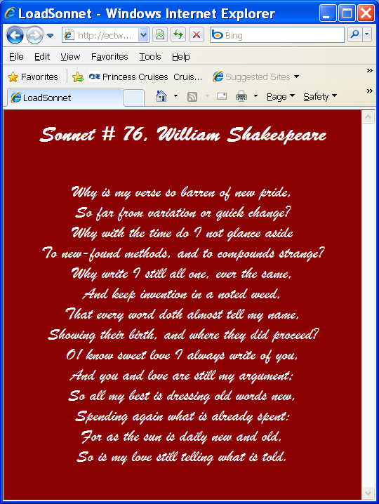 | Basics/loadfile.php  <html>  <head>  <title>LoadSonnet</title>  <style type = "text/css">  body{  background-color: darkred;  color: white;  font-family: 'Brush Script MT', script;  font-size: 1.5em;  text-align: center;  }  </style>  </head>  <body>  <div>  <?php  $fp = fopen("../Database/sonnet76.txt", "r");  //first line is title  $line = fgets($fp);  print "<h1>$line</h1>\n";  //print rest of sonnet  while (!feof($fp)){  $line = fgets($fp);  print "$line <br />\n";  } // end while  fclose($fp);  ?>  </div>  </body>  </html>

Loading the File into an Array
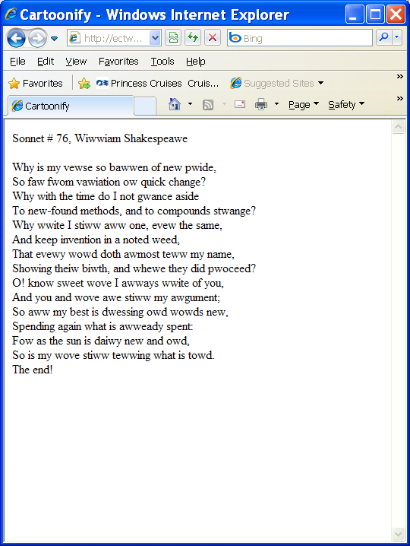 | Basics/filetoarray.php  <html>  <head>  <title>Cartoonify</title>  </head>  <body>  <div>  <?php  $fileName = "../Database/sonnet76.txt";  $sonnet = file($fileName);  $output = "";  foreach ($sonnet as $currentLine){  $currentLine = str_replace("r", "w", $currentLine);  $currentLine = str_replace("l", "w", $currentLine);  $output .= rtrim($currentLine) . "<br />\n";  } // end foreach  $output .= "The end!<br />\n";  print $output;  ?>  </div>  </body>  </html>

Working with Directory Information
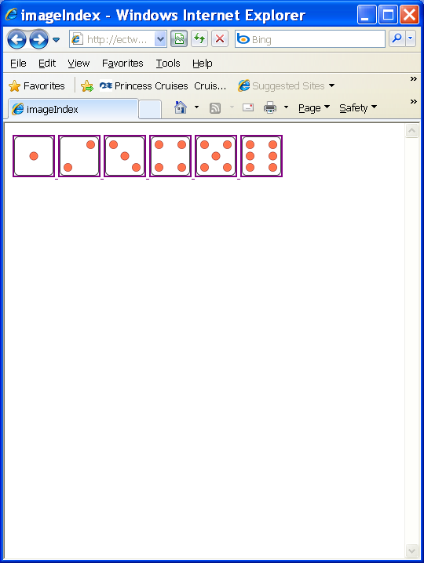  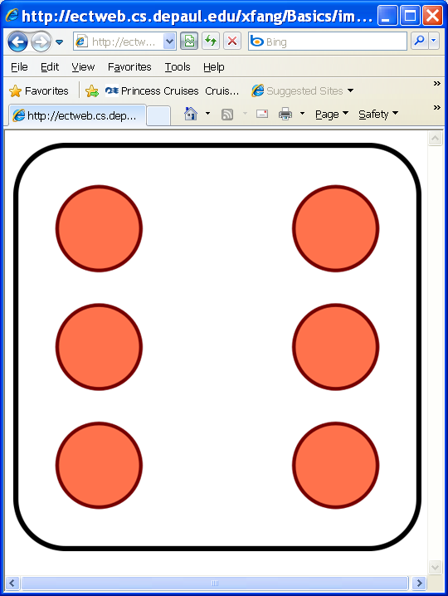 | Basics/imageindex.php  <html>  <head>  <title>imageIndex</title>  </head>  <body>  <?php  // image index  // generates an index file containing all images in a particular directory  //point to whatever directory you wish to index.  //index will be written to this directory as imageIndex.html  $dirName = "images";  $dp = opendir($dirName);  chdir($dirName);  //add all files in directory to $theFiles array  $currentFile = "";  while ($currentFile !== false){  $currentFile = readDir($dp);  $theFiles[] = $currentFile;  } // end while  //extract png images  $imageFiles = preg_grep("/png/", $theFiles);  $output = <<<HERE  <html>  <head>  <title>imageIndex</title>  </head>  <body>  <div>  HERE;  foreach ($imageFiles as $currentFile){  $output .= <<<HERE  <a href = "images/$currentFile">  <img src = "images/$currentFile"  height = "50"  width = "50"  alt = "$currentFile" />  </a>  HERE;  } // end foreach  $output .= <<<HERE  </div>  </body>  </html>  HERE;  print $output;  ?>  </body>  </html>

Uploading a File
Create a form: fileupload.html
<HTML>
<HEAD>
<TITLE>Upload a File</TITLE>
</HEAD>
<BODY>
<H1>Upload a File</H1>

<FORM METHOD="POST" ACTION="fileupload.php" ENCTYPE="multipart/form-data">
<p><strong>File to Upload:</strong><br>
<INPUT TYPE="file" NAME="img1" SIZE="30"></P>
<P><INPUT TYPE="submit" NAME="submit" VALUE="Upload File"></P>
</FORM>
</BODY>
</HTML>

Create a script: fileupload.php

<?php

if ($_FILES[img1] != "") {
@copy($_FILES[img1][tmp_name],
"../Database/.$_FILES[img1][name])
or die("Couldn't copy the file.");
} else {
die("No input file specified");}
?>

<HTML>
<HEAD>
<TITLE>Successful File Upload</TITLE>
</HEAD>
<BODY>
<H1>Success!</H1>

<P>You sent: <? echo $_FILES[img1][name]; ?>,
a <? echo $_FILES[img1][size]; ?> byte file with
a mime type of <? echo $_FILES[img1][type]; ?>.</P>

</BODY>
</HTML>

